SEEDLING MODERN HIGH NURSERY SCHOOL

PRE-PRIMARY

HOLIDAY CIRCULAR 2019 - 2020

Summer, Summer Is almost here,
Time for fun and big cheer.
What do we see when we think of Summer ?
Red, orange and yellow
Staying home, playing games
Being happy and mellow.
Trips to the ocean and river,
Camping, swimming, fun
Going, away to summer camp,
And naps under the sun.

Dear Parents,
Summer vacation is synonymous with fun, frolic, getting up late in the morning, playing for longer hours with friends, going for picnic, exploring new places and watching fun filled shows on television. But there is a lot more you can do to make your child’s vacation more interesting, meaningful and full of fun while still doing all your favourite things.
Children should be motivated to do Creative learning and Creative play. General awareness about things around us, at home, neighbourhood will add to their personality. Spend some quality time with your child, this will strengthen the bonding. This also helps the child to acquire good manners, confidence and discipline.
The children can be taught to be responsible and disciplined by doing simple tasks at home. So get ready for your treasure hunt, along with your parents.
Holidays are time when you can connect with your child in many ways. As parents are the first and the most important teacher for a child, we can encourage our child to participate in many educational activities at home and promote his/her quest to learn. Working together will not only help your child to build, learn and develop his/her skills but also strengthen your bond with him/her.
1. MORNING BLESSINGS:
Get up early in the morning and see the rising sun. Help your child inculcate good habits like doing “Surya Namaskar” and encourage him/her to greet all elders in the morning. If possible, visit a temple or any other religious place.

2. NATURE’S BOUNTY:
Nature is the most significant and an integral part of our lives. Cherishing and caring this Natures Bounty should be an integral part of every Seedlites life. Thus here is an amazing idea.
- Go for nature walk.
- Feel the fresh air- Take a deep breath and do breathing exercises.
- Hear the birds chirping.
- Water the plants and feed the birds.
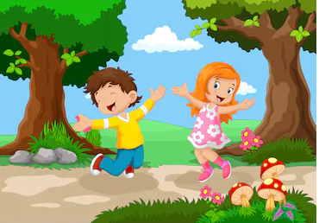
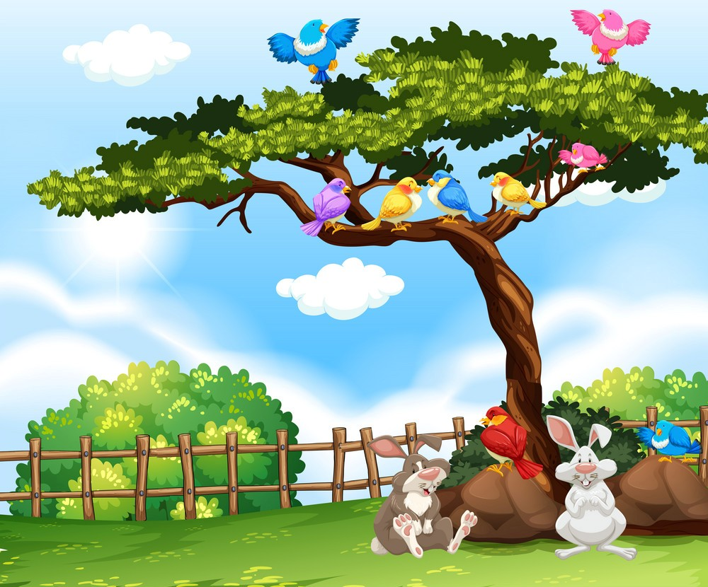

3. BEING INDEPENDENT:
Make your child more independent by teaching him/her various activities like:
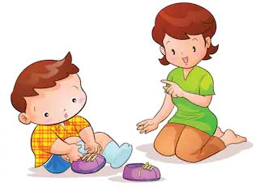
- Buttoning and unbuttoning the shirt.
- Laying the table.
- Folding mats and clothes.
- Arranging their toy shelf.
- Learn how to wear shoes and socks.
- Learn how to zip their school bag and clothes.
- Sorting and pairing household items.

4. FUN IN KNOWING:
- All Rhymes, Story, Topics of conversation and General knowledge done in the class to be revised.

5. WRITING ACTIVITY:
- All written work done to be practised on loose sheets.
- Write one page of Hindi and one page of English every alternate day to improve your handwriting. (U.K.G. and Prep)
- Kindly check the formation (letters / alphabets / numbers). Neatness and accuracy needs to be emphasized right from the beginning .
- Help the children to practice the following strokes on loose sheets.
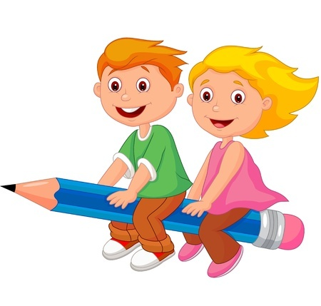
- (|, − ,/, \, U,) (L.K.G)

6. THINKING SKILLS:
This activity can help children to be creative and encourage them to come up with their own ideas and try a variety of solutions.
Activity – Single letter (Alphabet) a day
Objective – Building Vocabulary
- Choose a letter for the day for eg. “B”.

- Start the day by giving the child breakfast like :
Breakfast Banana and Brownie
Breakfast, Banana and Brownie begin with letter ‘B’
- Go to the park and look for the things like – Butterfly, Ball, Baby etc.

- End of the day let him/her count the total words by recalling all the words.

- Appreciate them for their effort.

7. GENERAL AWARENESS:
Discuss and find out the best possible method for your child to help himself/herself at the time of crisis . For eg..
- Lost in a mall.
- Locked in a room or washroom.
- Make your ward learn and remember his/her parents mobile number, house address etc. to make him/her independent and secure.

8. DO’S THIS SUMMER:
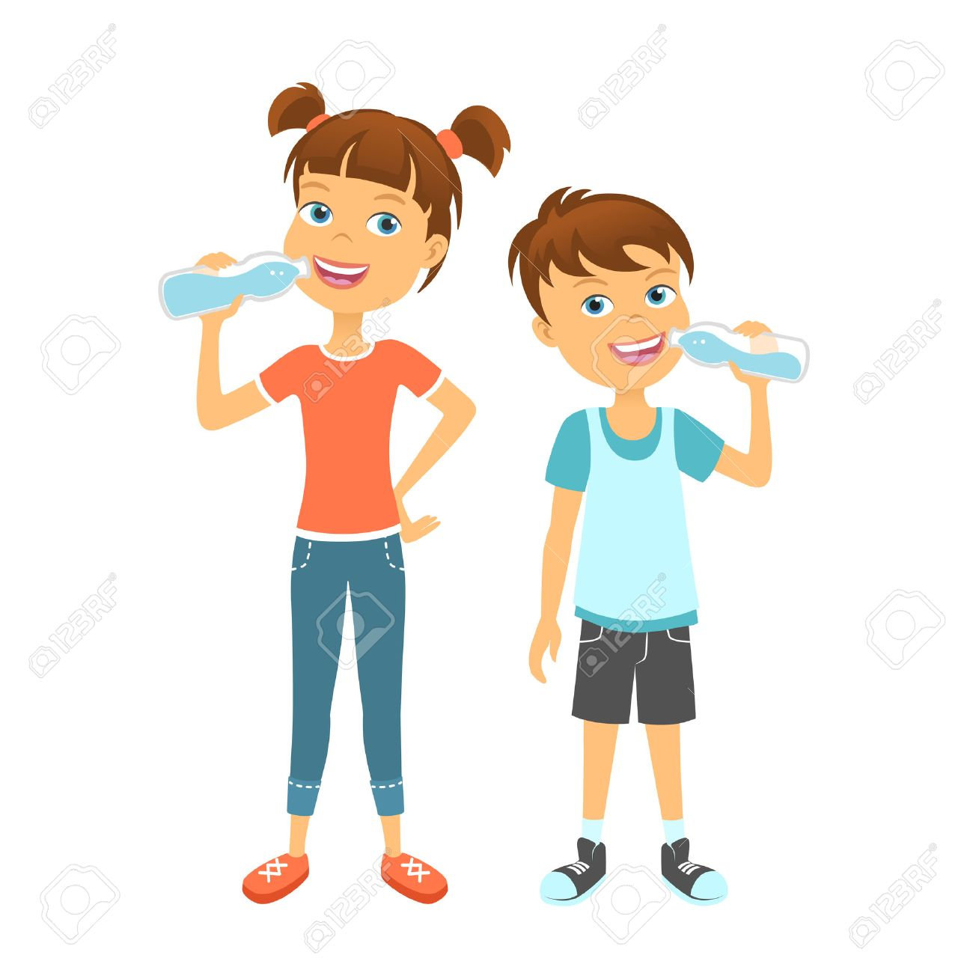
- Always start your day with prayer.
- Drink lots of liquids like water, juice etc.
- Eat lots of fruit and salad.
- Wish your elders and guests.
- Always turn the T.V off when you’re finished watching it.
- Always throw the garbage in the bins.
- Save all your newspapers, cans and bottles, Help your parents recycle them.
- Enroll your child in any one of the following activities to develop their hobby: swimming, dance, skating, etc.
9. DONT’S THIS SUMMER:
- Don’t watch T.V for long hours.
- Don’t eat junk food.
- Don’t play out in the sun.
- Don’t leave the refrigerator door open. Get what you want quickly and shut the door.
- Don’t leave the lights on when you aren’t in the room.

10. HAPPY FATHER’S DAY:
- Father’s Day is celebrated worldwide to recognize the contribution of fathers to the lives of their children.
- This day celebrates fatherhood for their selfless love and protection . To strengthen this bond let’s celebrate “FATHER’S DAY” .
Take help of your mother and plan a surprise by cooking something of his choice and make him feel special by giving him a card.
11. STAR PERFORMER :- ACTIVITY- I CAN HELP: In this activity children have the opportunity to gain self discipline and mastery by performing simple chores and taking responsibility for helping at home. Begin this activity by deciding what are the appropriate chores at home for your child. Give him/her a star if he/she performs that activity each day. You can make a chart, like the one given below. :-
 | Mon | Tue | Wed | Thur | Fri | Sat | Sun
I can water
The plants
I can arrange
My room
I can help
Mom
I love to
share

12. TRAVEL TIME ACTIVITY:
As children learn to observe their surroundings, they begin to both identify and distinguish between sounds, sights, tastes, smells, and sensations. They develop a sense of curiosity about themselves and the world around them.
We encourage our parents to point out, discuss and expose children to the world around them. First hand observation and hands-on exposure is the best way to give pre-scholars the foundation that they need for learning.
Directions:
- Once you are on a road-trip, talk to your children about the surroundings. If you are going through a village, you should explain that this is a village. Point out the fields, trees, flowers, animals, water bodies, local market, village hall, post office and explain what goes on there. Talk about what makes up and goes on in a village or any other area that you are crossing.

- As you're in the car, shopping at the grocery store, or waiting at the petrol pump, help your toddler to point to all the things he/ she sees. Help him/her to identify various shapes and colours.

- Children should be encouraged to ask questions. As we all know, having answers to questions is the first step towards satiating the basic thirst for knowledge.
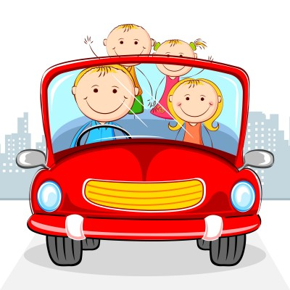

NOTE FOR PARENTS:
You are requested to make use of action words in your speech, like walking, sleeping, sitting, playing, dancing, eating, drinking, etc. Let your child also use these words in his/her speech. (eg. I am drinking, I am playing, etc.) Do not correct mistakes of your child when he/she is talking enthusiastically as this reduces their confidence.
Kindly Note: 1st July, Monday School commences after Summer Break.
Timing - 9:00 a.m. to 11:30 a.m.
Regular School Timing from 2nd July, Tuesday 8:40 a.m. to 1:00 p.m.

As parents, it is important to invest your time with the kids now.
With good wishes for a marvellous vacation.

School fee to be deposited by 30th June, 2019
Office will remain open during Summer Vacation.

Admission to all the classes are open as new section are being added in July. Siblings and friends will be given preference.

Mrs. Mohini Bakshi Dr. Preeti Bakshi Mrs. Rani Hooja (Principal Director) (Director) (Principal)

